Project step 1: Proposal

Xujian Zhang

**Project assignment:**

Hebb neural network for letters and numbers recognition

**Background information:**

Visual pattern recognition, such as reading characters or distinguishing shapes, can easily be done by human beings, but it is very difficult to design a machine which can do it as well as human beings do. We believe that the best strategy is to learn from the brain itself (KUNIHIKO, 1987). We are studying the mechanism of visual information-processing in the brain, and trying to use it as a design principle for new information processors (Fukushima & Miyake, 1982). More specifically, we are studying how to synthesize a neural network model which has the same ability as the human brain. As a result of this approach, a pattern-recognition system called the "neocognitron" has been developed (Fukushima, 1980).

Artificial neural networks represent a type of computing that is based on the way that the brain performs computations. Neural networks are good at fitting non-linear functions and recognizing patterns. Consequently, they are used in the aerospace, automotive, banking, defense, electronics, entertainment, financial, insurance, manufacturing, oil and gas, robotics, telecommunications, and transportation industries.

**Project desired objectives and goals:**

Users could provide three .txt files, one test_data file is the test file which has several matrixes made by 0 and 1 (formatted such as 9*7, 8*10). The other two (training_data and target_data) is used to compare to these matrixes and the machine could recognize is the matrix represent a letter or a number or nothing.

The test_data.txt, training_data.txt and target_data.txt need to look like this:

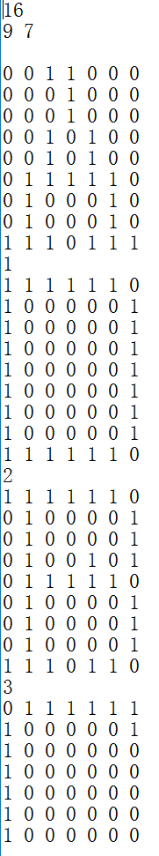 test_data 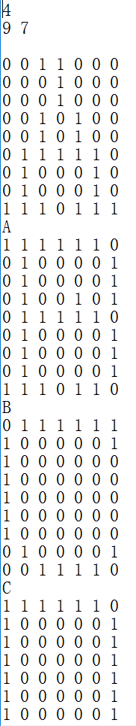 training_data 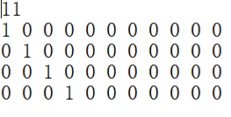 target_data

**Preliminary description of the software:**

In the beginning, users can choose the files (test_data, training_data and target_data) they provided and the software will respond them is there any letter or number in the file of test_data.

In the software, it will receive three .txt files. Next the software will transfer the data from training_data as a two-dimensional arrays S[k][i], target_data as T[k][j] and calculate the two arrays to generate a new array w[i][j]. After that the software will calculate the two arrays w[i][j] and the patterns[p_test] from test_data. Finally, the result will compare to the y[k][j] and T[k][j] to get the result.

**Preliminary** **pseudocode:**

Choose the training_data.txt

Create s[k][i]

Choose the target_data.txt

Create T[k][j]

Calculate s[k][i] and T[k][j]

Create w[i][j]

Choose the test_data.txt

Create patterns[p_test]

Calculate patterns[p_test] and w[i][j]

Create y[k][j]

Compare y[k][j] and T[k][j]

Print result as y_out.txt

**References:**

Fukushima, K. (1980). Neocognitron: A self- self-organizing neural network model for a mechanism of pattern recognition unaffected by shift in position. Biological Cybernetics. 36(4), 193-202.

KUNIHIKO FUKUSHIMA. (1987). Neocognitron: A Hierarchical Neural Network Capable of Visual Pattern Recognition. NeuralNetworks, Vol. 1, pp. 119-130.

Fukushima, K., & Miyake, S. (1982). Neocognitron: Anew algorithm for pattern recognition tolerant of deformations and shifts in position. Pattern Recognition, 15(6), 455-469.